1.  Prepare your flash drive.

2.  Go to google drive, under digital forensic software, copy the test 2 folder on your clean flash drive.

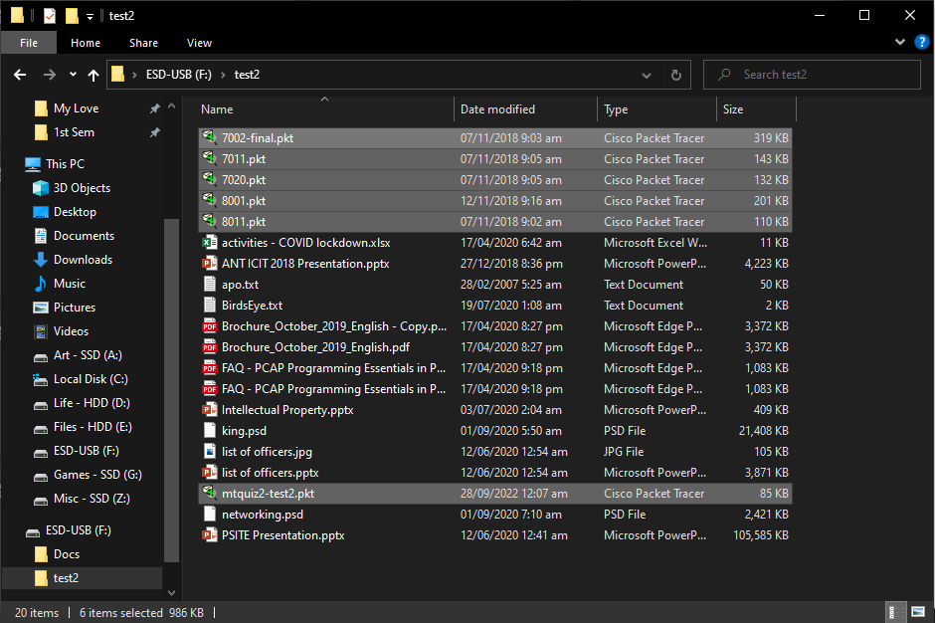

3.  Go to your flash drive and erase all packet tracer files. Take a screenshot of the files deleted

Proof that Files have been deleted

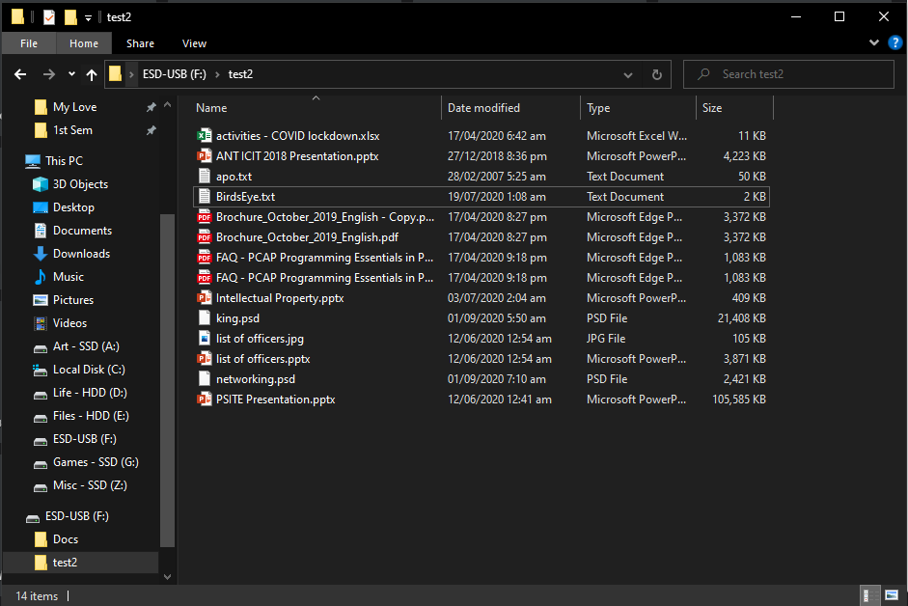

4.  Using your pro-Discover or Access Data FTK, recover the mtquiz2-test2.  Take a screenshot of the steps in recovering the file.

Creating an image of the USB drive

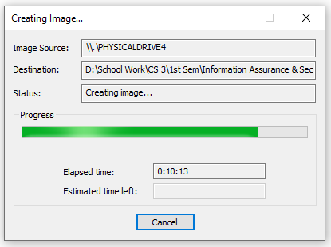

Verifying that evidence is unchanged

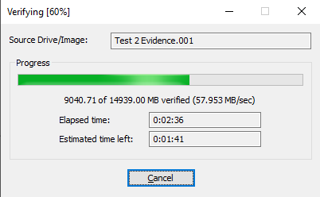

Proof that evidence is unchanged

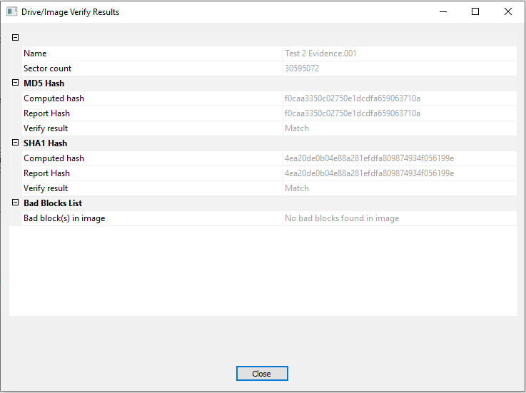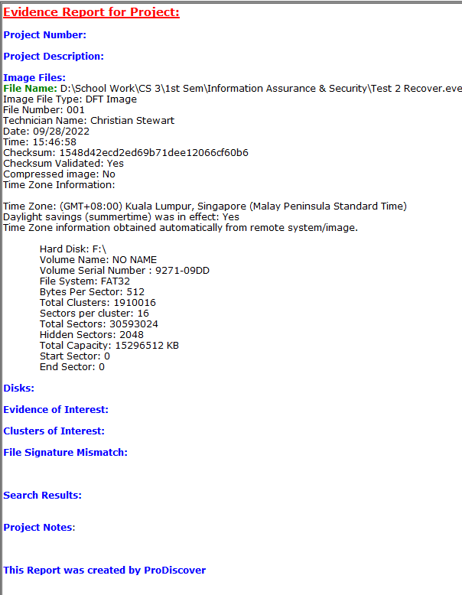

Summary of Findings

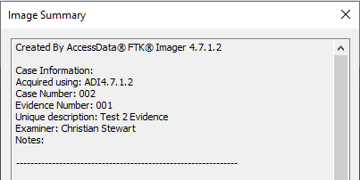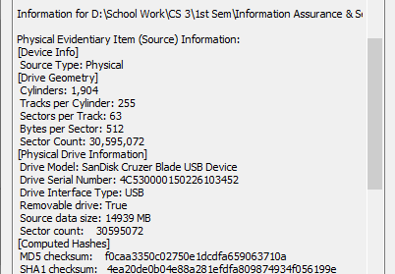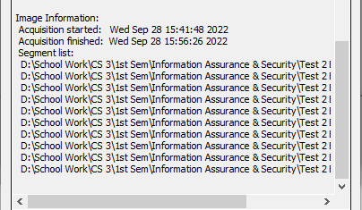

Viewing of Evidence and Deleted Files

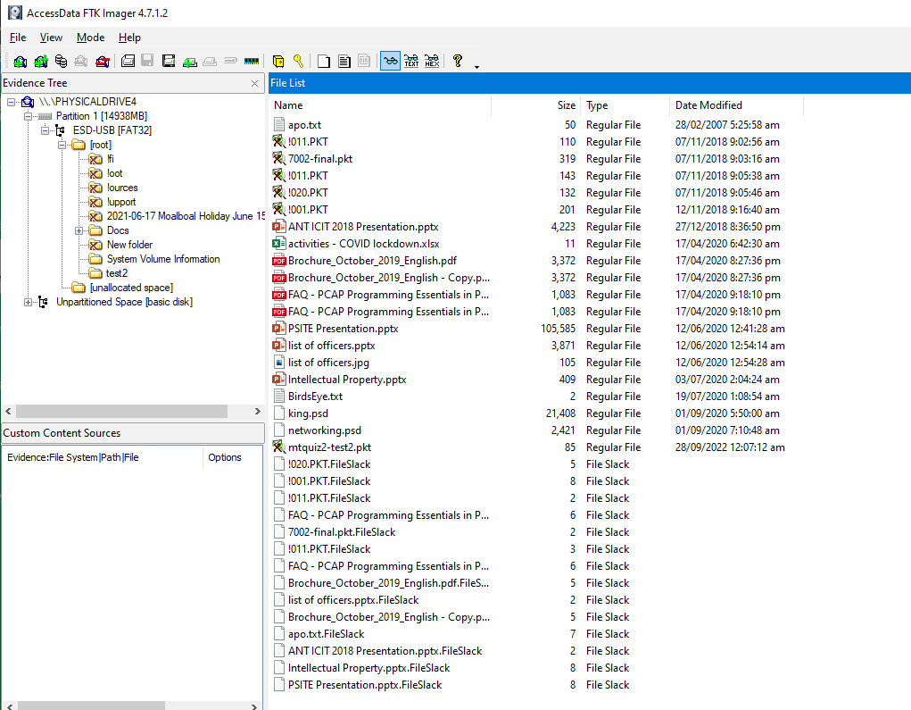

Text File as Proof

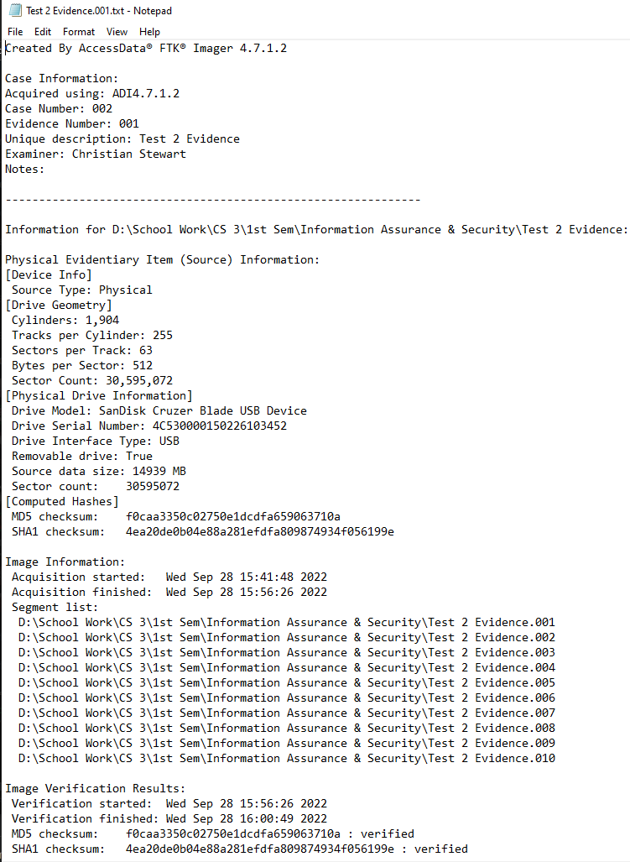



Proof that File has been recovered

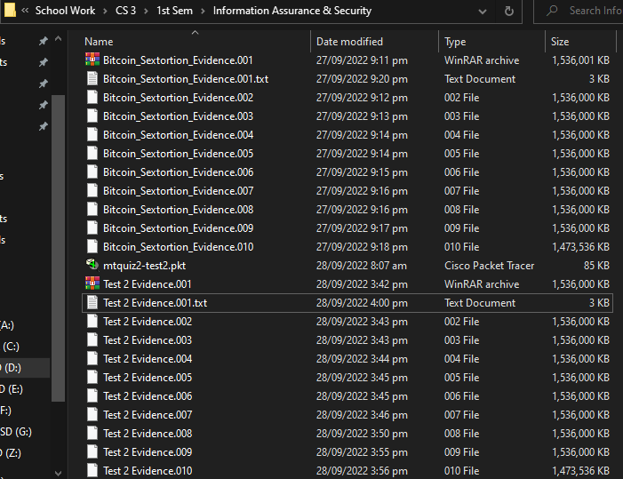

5.  Once recovered, use the password for your Test 3 Exam, it is the password in the line vty 0 4.

Proof that password has been found

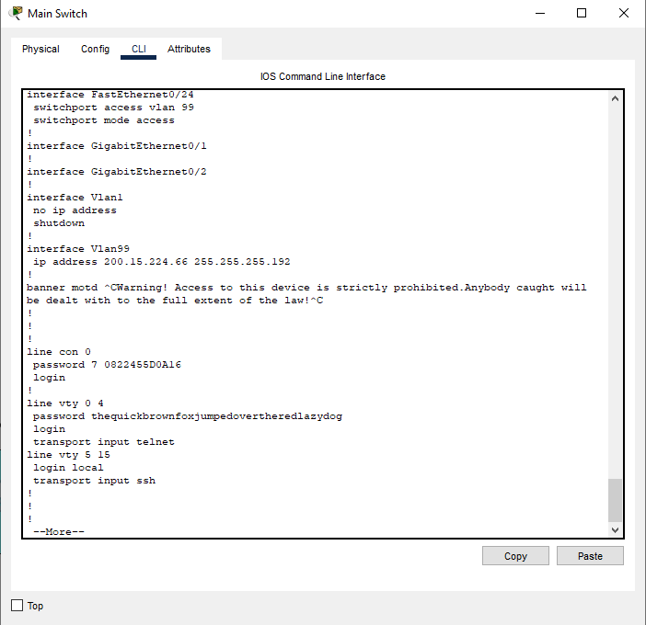

**thequickbrownfoxjumpedovertheredlazydog** is the password

6.  Start taking the MT Quiz2: Test 3